**Text to Columns Tutorial**

Below are the results for the first 27 games played by WVU’s Men’s Basketball team in the 2017-2018 season. The “Result” column (Column B) includes the following information: (1) Whether WVU won or lost the game, (2) the number of points scored by WVU, and (3) the number of points scored by the opponent. The purpose of this tutorial to illustrate how these pieces of information can be placed into their own, individual columns.

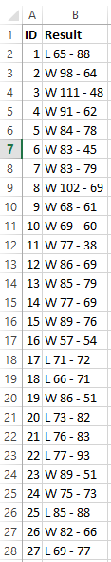

Step 1: Highlight contents of the “Results” column.

Step 2: Move to the “Data” tab, which is located in the top toolbar.

Step 3: Click on “Text to columns.”

Second, move to the “Data” tab

Third, click on “Text to columns”

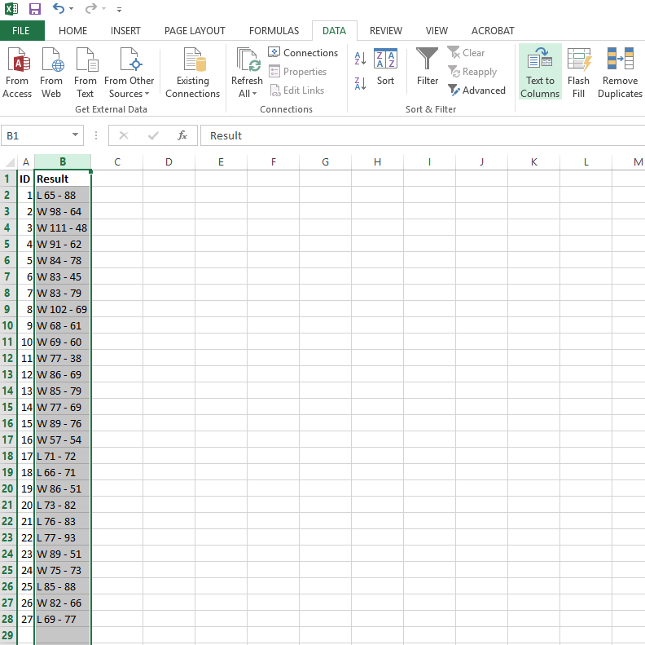

First, highlight the contents

Step 4: Select “Delimited” and click “Next”

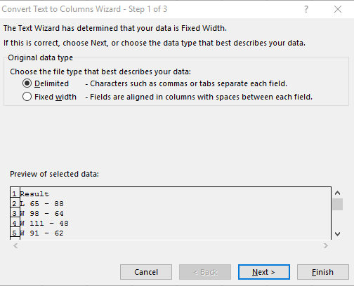

Step 5: Check the “Space” box only and then click on “Finish”

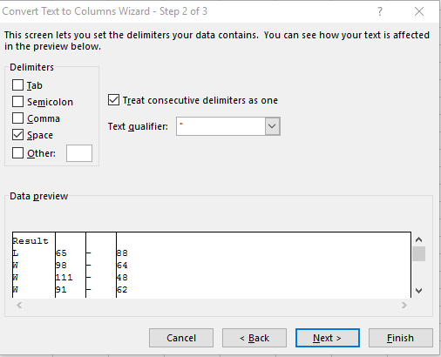

End result: The three pieces of information that was originally located in the “Result” column is now separated into individual columns

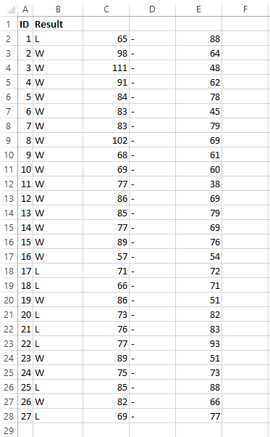

Following a bit of cleaning and a quick VLOOKUP to dummy code the new “Result” column (where L = 0 and W = 1), the data will look like this. Now the data are ready to be analyzed in R.

